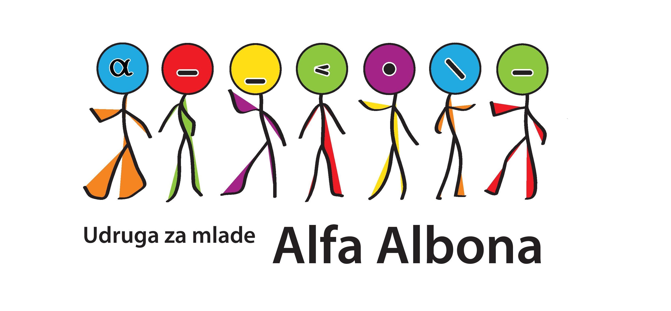
YOUTH EXCHANGE:
»MASQUERADE«
Labin, CROATIA 25. – 31.08.2014.

- APPLICATION FORM -
Name and surname:
Date of birth:
Address (streetn name, number, town):
Cellphone number:
E-mail:
Occupation:
Level of english language:
Are you familiar with the previous European comission programme Youth in Action or the new one Erasmus + and have you ever participated on some project or activitiy within the programme?
Describe shortly and clearly your motivation and experience in the area of art or street performance.
What would be your personal aims and expectations for this exchange? What would you want to learn/gain from this experience?
Specify any food requirements that you have (vegetarian, allergies, etc) and any requirements that you have (mobility, medical condition, religious, etc). Otherwise leave blank.

Are you a part of any association? If yes, write which one and what is your role in it.

Application form send to alfa.albona@gmail.com with subject »Prijava za razmjenu mladih Masquerade« till 10th of August 2014.
Hope to see you in LABIN! :)

